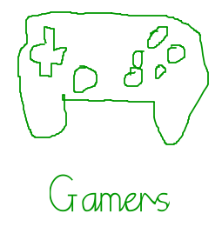

Issue 1 – 28/10/16

Halloween offers - <http://store.nintendo.co.uk/ninint/email/2016-10-26-Monthly-October-Group-3/email.email> view this link to get £5 off when you spend £30. Promo code: BOO5

What we’ve been waiting for! – Nintendo has finally released a YouTube video of their next console/handheld device.

Watch this video and see the cool things it can do…[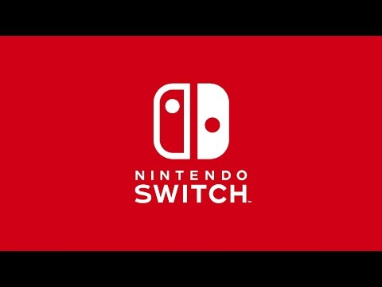](https://www.youtube.com/watch?v=3c6MWsEE884)The two games we have been waiting for! – Paper Mario: Color Splash and Mario Party: Star Rush (a.k.a. Mario Party 14) made their debut on the 7th October 2016.



Copyright 28th October 2016 [Visit website](http://lynxarlo67.wixsite.com/gamers)